Overview Database
The database activity module enables participants to create, maintain and search a collection of entries (i.e. records). The structure of the entries is defined by the teacher as a number of fields. Field types include checkbox, radio buttons, dropdown menu, text area, URL, picture and uploaded file.
The visual layout of information when listing, viewing or editing database entries may be controlled by database templates. Database activities may be shared between courses as presets and a teacher may also import and export database entries.
If the database auto-linking filter is enabled, any entries in a database will be automatically linked to where the words or phrases appear within the course.
A teacher can allow comments on entries. Teachers or students can also rate entries (peer evaluation). Ratings can be aggregated to form a final grade which is recorded in the gradebook.

Setting up the Data Base
- Turn editing on.
- Add an activity or a resource.
- Give a concrete name.
- Description. (Instructions)
- Entries
Approval required: Students need your approval before they can enter into the database.
Allow comments in entries: Students are able to comment on other entries.
Entries required before viewing: Number of entries a student needs to have before they can view the others. (set at least 1)
Maximum number of entries: Even if you want the student just to do one entry, set this at two so they can go back and edit.
- Availability (usually no date unless it is a marked activity).
- Restrict Access (if you have more than one class using the Moodle course site use grouping).
- Activity Completion keeps the student on track.

You’re half way to setting up your Database. Now you need to set what the database will look like by setting up fields.
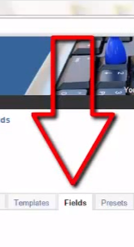
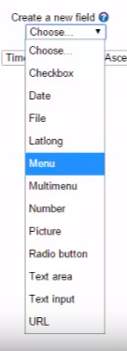

You can have as many fields as you would like.
Checkbox: list of items; students can check as many as they would like.
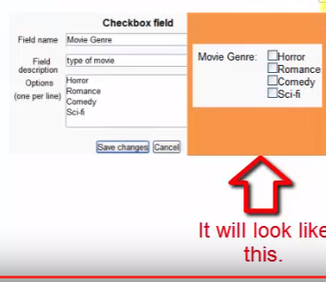
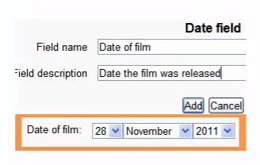
Date: enter date

File: drop a file
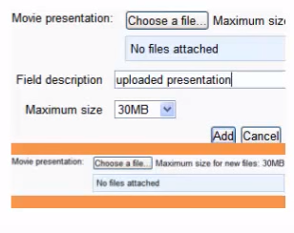
Latlong: put in latitude and longitude and link it to a Google map; doing so will pull up that specific location.
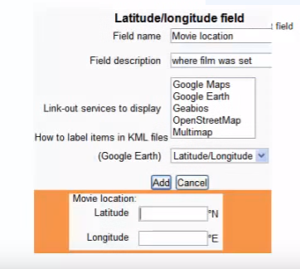

Menu: choose from a list of items.

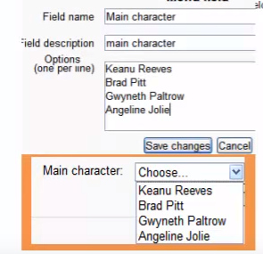

Multimedia: choose one or more from a list of items.
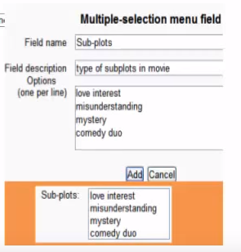

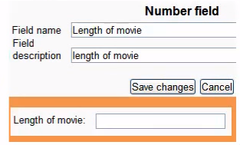
Numbers:

Picture: upload a picture (instructor chooses the size in pixels).

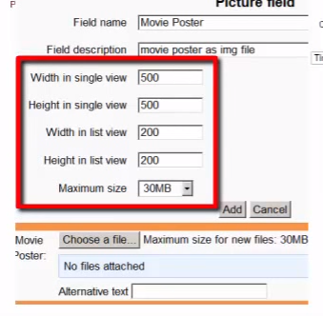

Radio button: circle buttons you can click on similar to a checkbox.
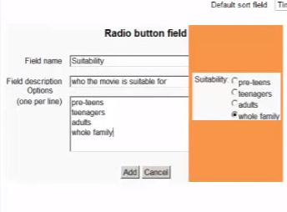
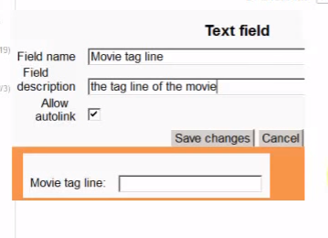
Text area: limited to 60 characters (good for titles)

Text input: longer text passages
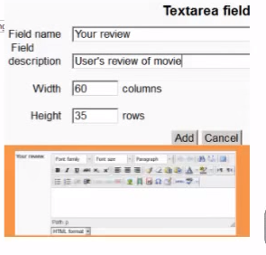
URL:
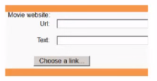

After you have chosen your fields, go to template and click Save template.

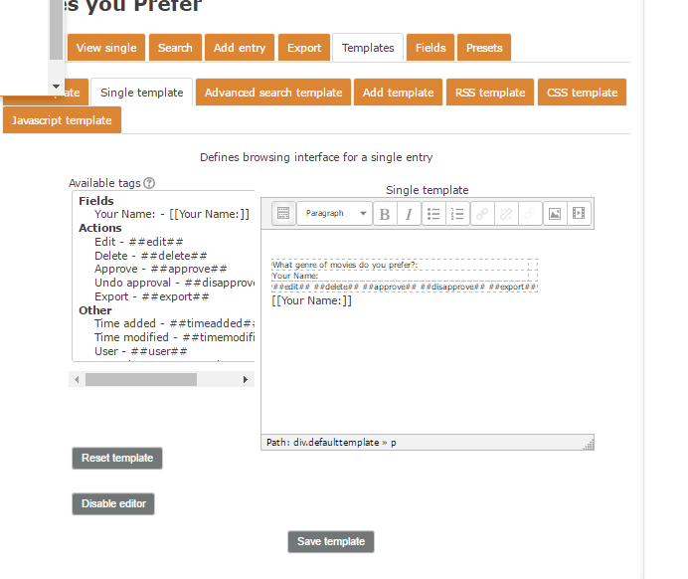
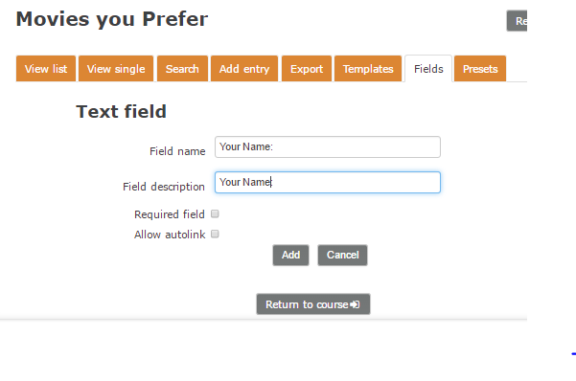

You can also try some templates for databases.

For more information, see the Database Activity Module in Moodle docs or consult with Moodle Help.

